EXP:9
Shared Memory IPC
CODE:
#include <stdio.h>
#include <sys/ipc.h>
#include <sys/shm.h>
#include <string.h>
int main(void) {
int id = shmget(IPC_PRIVATE, 256, IPC_CREAT| 0600);
char *p;
if (id < 0) {
perror("shmget");
return 1;
}
p = (char*)shmat(id, NULL, 0);
if (p == (char*)- 1) {
perror("shmat");
return 1;
}
strcpy(p, "Message stored in shared memory");
printf("Reader received: %s\n", p);
shmdt(p);
shmctl(id, IPC_RMID, NULL);
return 0;
}
OUTPUT:
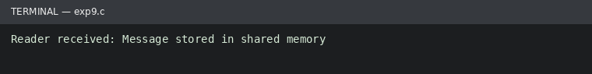
Run status: Ran successfully

